George Fryback
October 17, 1826 – June 19, 1906

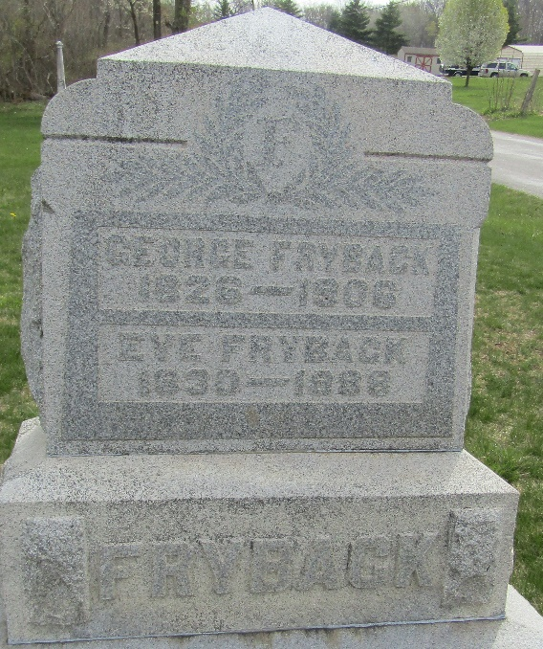

George Fryback
in the Indiana, U.S., Death Certificates, 1899-2017
Name George Fryback
Gender Male
Race White
Marital Status Widowed
Age 79
Birth Date 17 Oct 1826
Birth Place Ohio
Death Date 19 Jun 1906
Death Place Wells, Indiana, USA
Death Registration Date 1906
Father George Fryback
Mother Susan Deam
Spouse Eva
Informant Frank Fryback; Ossian, Indiana
Burial June 21, 1906; Murray Cemetery

